Output:
--- Audio Signal Metadata ---
Sampling Rate: 44100 Hz
Total Samples: 786410
Duration: 17.832 seconds
Max Amplitude: 1.00
Min Amplitude: -1.00
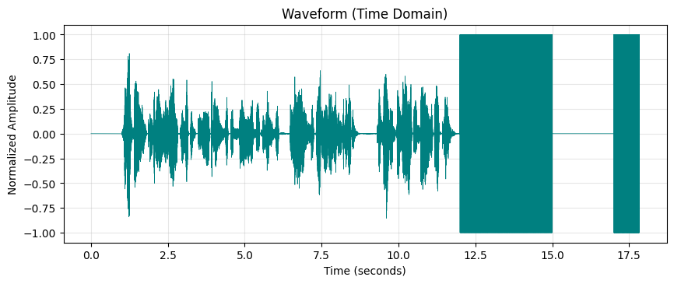
Figure 1: Time-Domain Waveform of Speech Signal

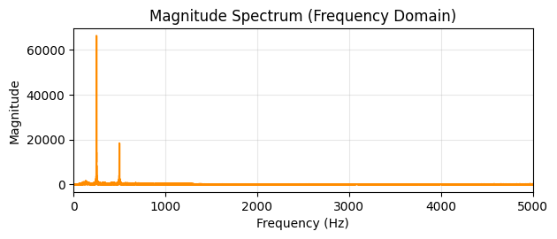
Figure 2: Magnitude Spectrum of Speech Signal

Output:

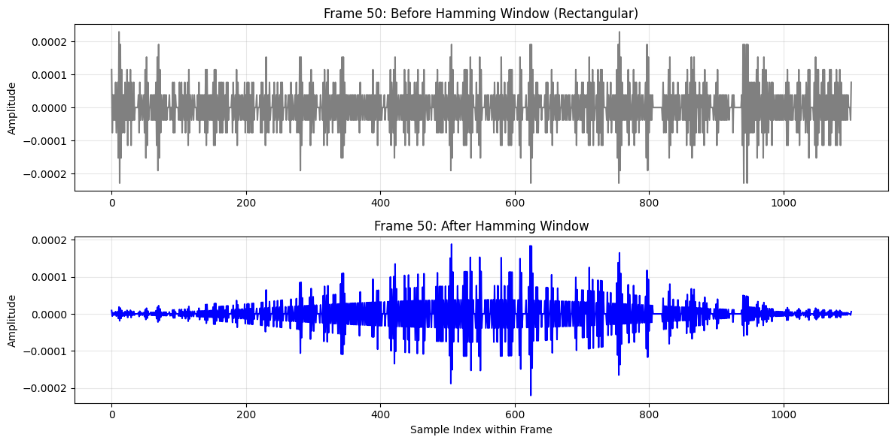
Figure 3: Frame 50 of Speech Signal Before and After Applying Hamming Window

Output:

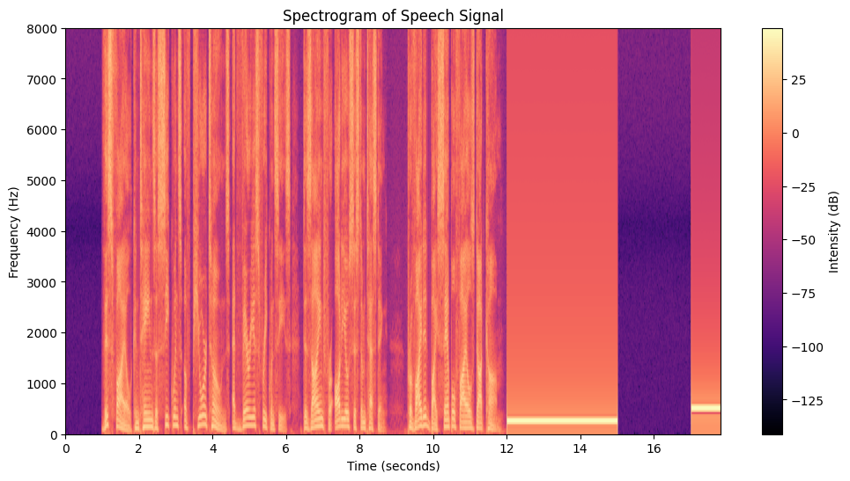
Figure 4: Spectrogram of Speech Signal Using Short-Time Fourier Transform

Output:
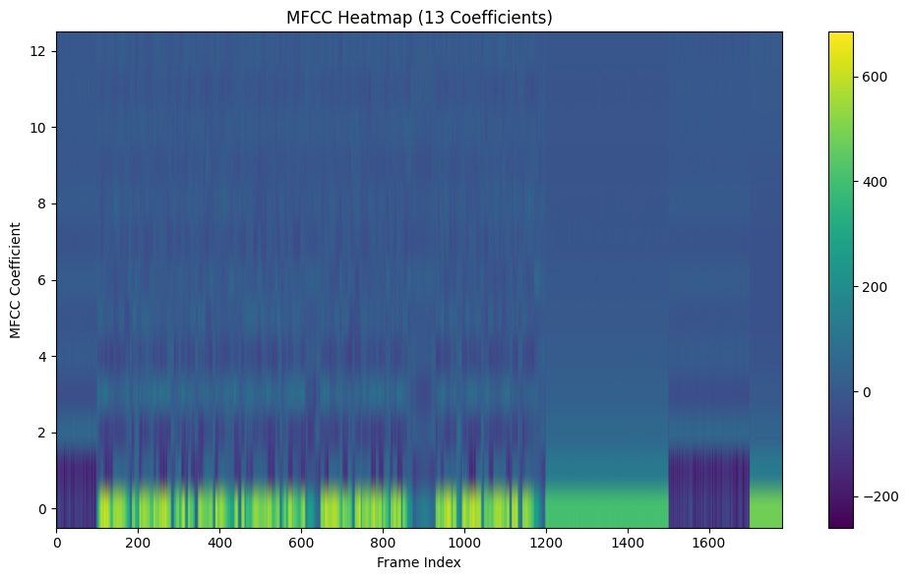
Figure 5: MFCC Heatmap of Speech Signal

Output:

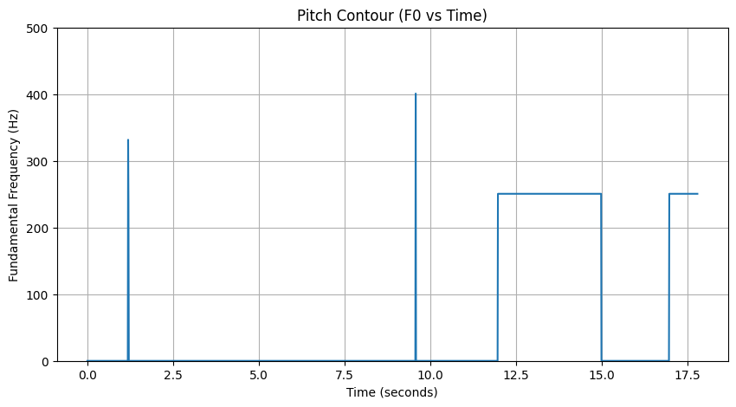
Figure 6: Pitch Contour of Speech Signal

